

**E-Yantra Robotics Competition - 2017**

**Theme and Implementation Analysis – TB**

**#3322**

|  |  |
| --- | --- |
| **Team leader name** | **Raghav Goel** |
| **College** | **Jamia Millia Islamia** |
| **Email** | [**raghavgoel024@gmail.com**](mailto:raghavgoel024@gmail.com) |
| **Date** |  |

**Scope and Preparing the Arena**

**Q1 a. State the scope of the theme assigned to you. (3)**

The theme which is assigned to us is **Transporter Bot** that is related to bringing the automation in the field of agriculture by transporting the farm’s stuffs (like fruits and vegetables) from farm to market/storage on proper time with the help of robots & machines.

Transportation is an important part of agricultural activities.

Following points are the advantages & scope in agriculture sector by using the Robots in transporting:

* **Human Efforts :**

By bringing the Robots in transporting quantity of humans & labour get reduced.

* **Time Delay:**

Robots can perform their work without any delay & can easily work for long hours.

* **Mistake & Handling:**

The error get reduced using robots & Handling of heavy load is also so easier than before.

* **All Time Availability :**

Robots are available 24hrs so whenever we need we can simply wse them.

1. **Attach the Final Arena Images. (20)**

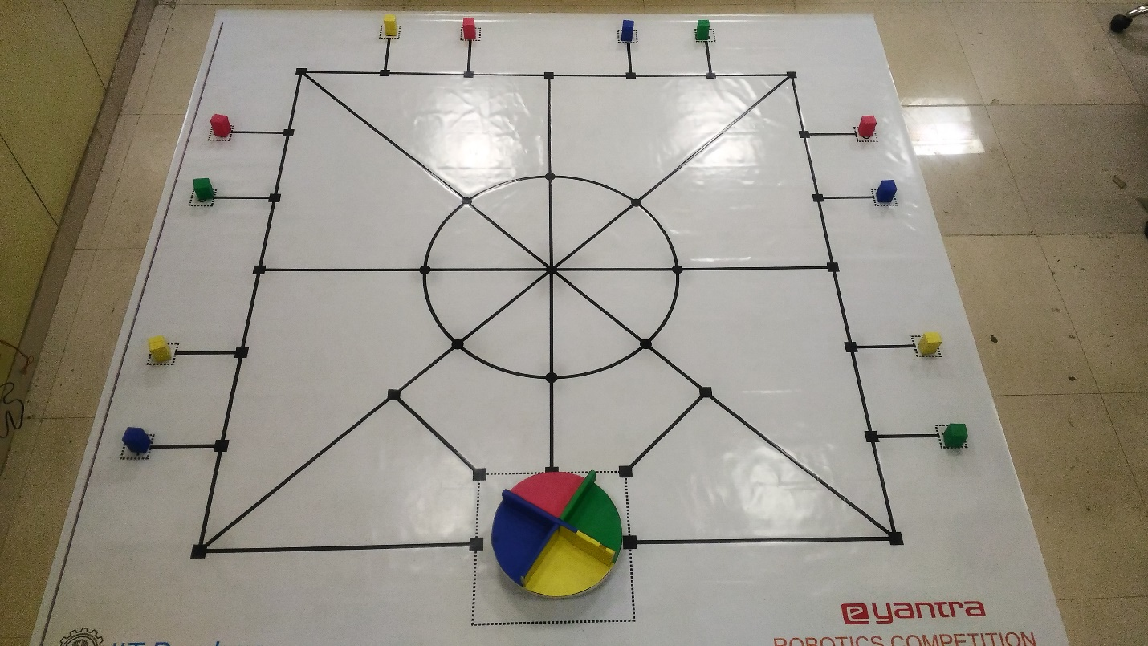

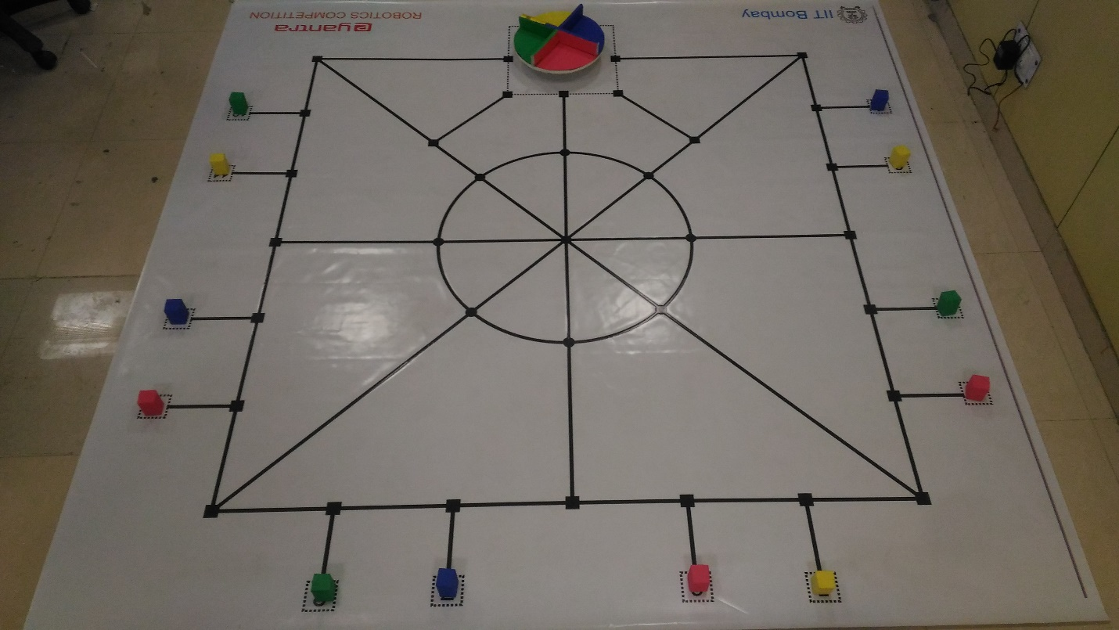

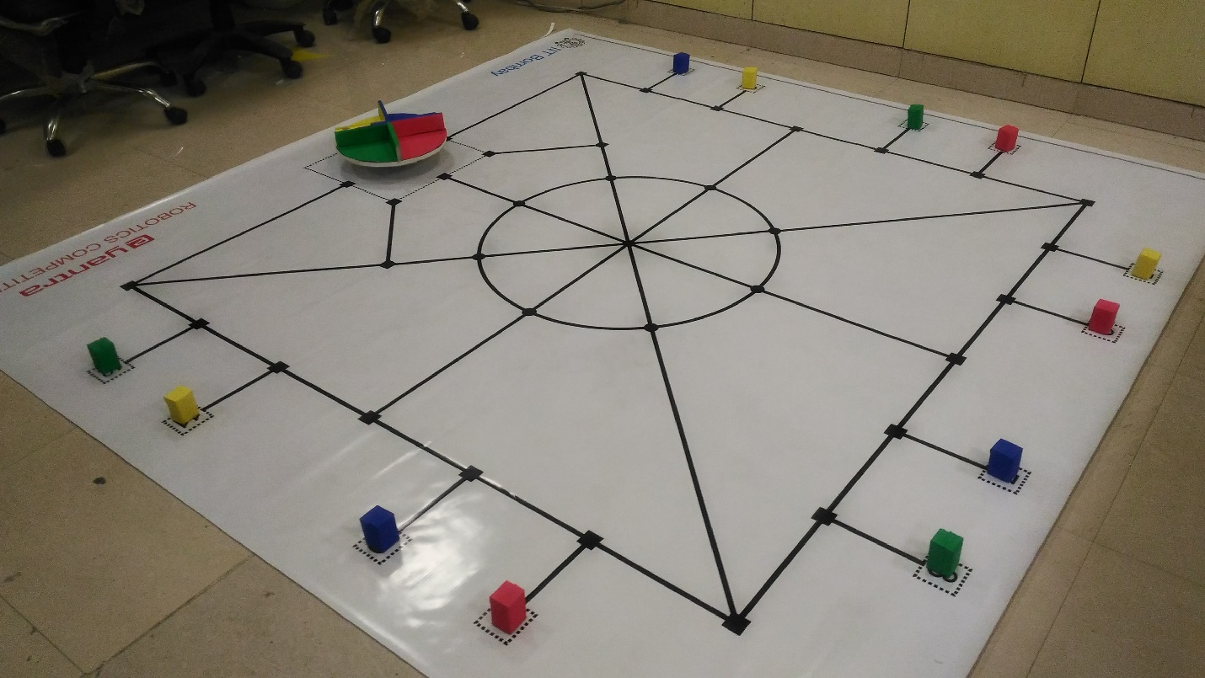

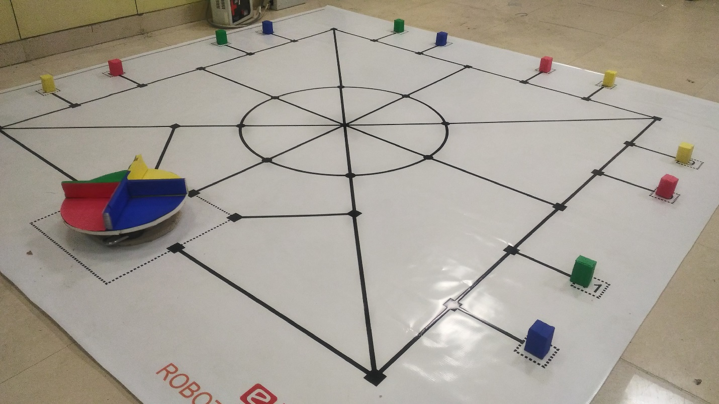

**Building Modules**

**Q2. Identify the major components required for designing the robotic system for the theme assigned to you. (5)**

**Components required for Gripper (picking & dropping mechanism):**

1. Mechanical Components:

1. Gears
2. Arms

2. Electrical components:

1. Servo Motor
2. AtMega2560 (for operation of Motor)

**Components needed for collecting blocks on robot:**

1. Mechanical Components:

i) Gears

ii) Rotating wheel

iii) Screws

2. Electrical Components:

i) Dc Motors

ii) AtMega2560 (for operation of Motor)

**Components Requires for Deposition Zone:**

1. Mechanical Components:

i) Rotating wheel

2. Electrical Components:

i) Stepper Motor

ii) Arduino Nano

iii) L298N Motor Driver

iv) Xbee Module

v) Battery

**Components require to interface with Blender Via Laptop:**

Xbee Module

**Actuators**

**Q3. List all the actuators present on Firebird V robot. Besides the existing actuators, please mention any additional actuators that may be required for implementing a solution for the theme. (5)**

**(i) Actuators that are already present on Firebird V robot:**

**1. Dc geared Motor:**

There are **two** DC Geared motors are present below the robot’s chaises at back , one at left side and other at right side of the chaises.

One wheel is implemented to each motor along with position encoder on both the motors.

These actuators are responsible for all types of motion of the robot, the front side of the robot is supported by a free caster wheel.

**Description of DC Geared Motor:**

Type - DC Geared

Speed - 75 rpm (Revolution per minute)

Controlled by - L293D dual motor driver.

Voltage supplied - 8-11.3 volt

Current supplied - up to 600mA (from L293D to each motors)



**(ii) Actuators that we need to interface with the Robot:**

**1. Servo Motor:**

We need two servo motors to design the picking & the dropping mechanism of blocks (crates).

we are using one servo for grabbing blocks which is attached to an arm & another servo we are using for adjusting the height of the arm.

**Description of Servo Motor:**

Type - DC

Speed - 0.28 to 0.31sec / 60 deg at no load

Voltage supplied - 4.8 to 6 volts

Current supplied - ~2000mA

Torque- 13-15Kg.cm

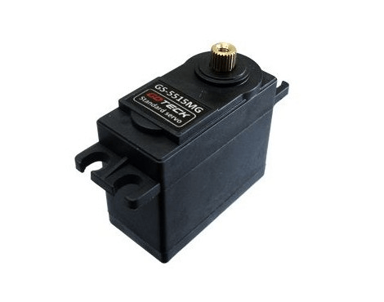

**2. Stepper Motor:**

We are using a Stepper Motor for our theme in which it has been used in rotating structure of the assigned theme

**Description of Stepper Motor:**

Type - DC

Steps/revolution - 200

Controlled by - L298N motor driver.

Voltage supplied - ~12 volt

Phase - 2

Current - ~2A (from L298N motor driver)

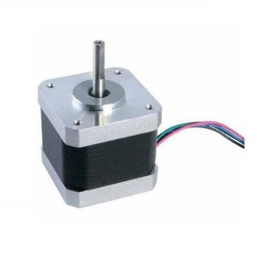

**3. DC Motor:**

We are using two dc motors for for the collecting mechanism which would be mounted on the FirebirdV one is to synchronize the colour & one is to drop the blocks in the Deposition zone .we use DC motor as per our requirements in future which would power by an appropriate motor driver.

**Power Management (2)**

**Q4. Explain the power management system required for a robot in general and for Firebird V robot in particular.**

We are using on board 9.6V NiMH battery pack for the powering of the robot which supplies 12V when it has been full charged & 8V when it get discharged & can supply maximum current up to 2amps, we are using battery mostly instead of using auxiliary power source because it is easy to move & test the robot with battery as compare of auxiliary powering source.

**Design Analysis**

**Q5.** **Teams have to design a mechanism for picking and dropping the Blocks into the Rotating Structure.**

1. **Choose an** **option to position the mechanism on the robot and justify your option (4)**
2. **Front 2. Back 3. Right/Left**

**Answer: _______Left____**

our gripper mechanism will be mounted on the left side of the robot.

**Reason:**

* As per our setup of track navigation and picking algorithm , all of the blocks (kept at pick up points) will lie at left side of the robot.
* on mounting the same at front or backside of the robot we have to take a 90 degree turn on reaching at the nearest node of each pick up points which would require more time and more collabaration.
* on turning the robot left/right posibility of commiting error in picking up the blocks will be increased because of dispositioning of robot.

By placing the mechanism of gripping the blocks on left side we could overcome these issues.

**working of gripper mechanism on plcing it at the left side:**

The purpose of the mechanism is to pick up the blocks from various pickup points and drop it at specified deposition zone.

on reaching at the nearest node such that the arms of the robot will be tilted to the left side through one servo motor and after positioning the gripping tool (section that will grip the boxes to pick it) one more servo will be used to grip the block, then the arms will become straight and it will drop the block on right side in the specified space mounted on the robot (above the robot) .

we are picking all the blocks at a time from various pick up point and these picked up blocks will be stored on a storage space (having 4 departments for each colour of boxes )

mounted on the robot, once all the blocks are picked up the robot will reach at deposition point and the blocks will be deposited to the specified space (colour wise) by titling the

storage section from one side .

1. **Explain the design of the mechanism and how it is mounted on the robot. (4)**

**Design of the mechanism:**

Gripping mechanism:

* The gripping mechanism is mounted on the left side of the robot.
* An arm (arm 1) is fixed on the bot and extended towards left side to make a gap between bot and gripper (because the storing mechanism will be mounted just above the Bot), that arm will be mounted/fixed to the bot by screw, Velcro, clips etc.
* Then another (arm 2) will be fixed (through screw) at free side of the arm 1 to provide a certain height.
* One more arm (arm 3) will be attached (hinged) to the arm 2 through a servo motor ( say Servo 1) by which arm 3 could rotate 180 degree about arm 2 to reach near The block.
* At the free end of arm 3 a gripper containing two sections is attached which could be rotated like a scissor to grip and drop the block, this rotation will be done through another servo motor (servo 2).

For picking up the block the gripper will reach near the block by using servo 1 then, object will be gripped using servo 2 and now for dropping, it will reach near the dropping space

Through servo 1 then the grip will be loosed through servo 2 and block will be dropped at specified space.

Collecting/storing Mechanism:

This mechanism is used to store all the picked up blocks on the bot for temporary by which we could pick up all the blocks at a time from various pick up points.

It will be made up of circular disk having four sections mounted above the bot using spacers , a DC motor will be attached at its centre , which would be rotate as per requirement(to deposit same colour at one section).

After collecting all the blocks the bot will reach at deposition zone and the disc on the bot having all the picked blocks will be raised up from one side(front) by linear actuator such that the blocks of same colour will be deposited at specified space of rotating structure(from back side of bot), further disc will be adjusted by rotation to deposit blocks of another colour.

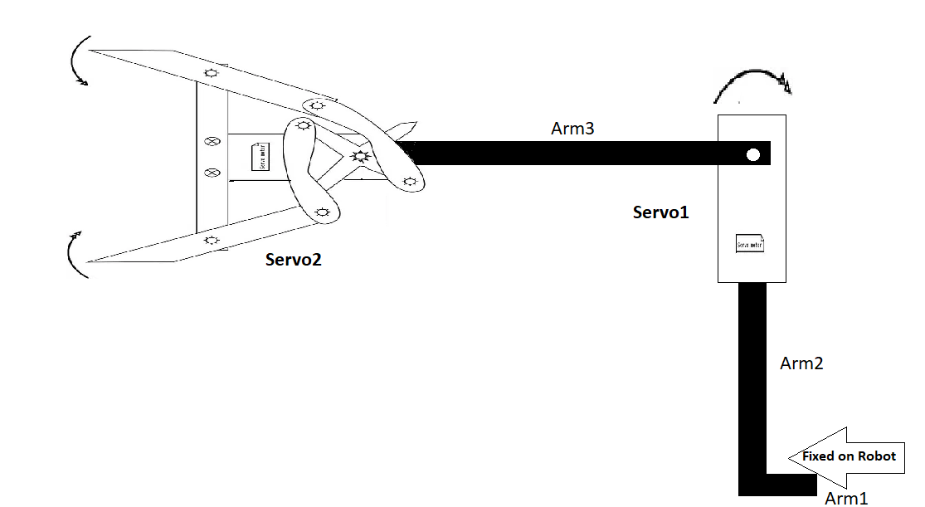

1. **To design the mechanism for picking and dropping the Blocks, what challenge/s do you expect to face and how you will overcome them? (2)**

**1. Direction of gripper:**

Challenge:

In this we face the problem where we should fix the whole mechanism & which side would be effective & efficient in respective of time so that in less time maximum output of work can be taken.

Solution:

We solve this problem by rotating the robot again & again by this we found that left side of the robot would be perfect for fixing the mechanism.

**2. Height of mechanism:**

challenge:

It was essential to give it a perfect height , to reach at the block perfectly .

Solution:

We had some trials to check the perfect height of the mechanism such that it could reach near the block and do not disturbs the motion of the robot.

**3. Mounting of mechanism:**

Challenge:

It was a big challenge how to mount the mechanism on given firebirdV5?

Solution:

we mounted the mechanism on the bot such that it could be rotated freely , arm

is fixed to the bot by screw,clips etc.

**d) Choose the actuator/s you will use to design the mechanism. (2)**

1. **DC-Motor 2. Servo Motor 3. Stepper Motor 4. Others**

**Answer: ______Servo Motor______**

we have used two servo motors for the gripping mechanism.

* Servo motor rotates 180 degree with high torque , in gripper mechanism we only have to rotate the arms and these rotation will be only upto 180 degrees.
* The size of servo motor is small as compared to other motors.
* DC motor can’t be used because it will be very dificult to rotate a DC motor for a certain degree of rotation.
* Stepper motor usualy have high weight than other motors it also draws maximum currents.
* In gripper mechanism we are not using only circular rotatary motion , our mechanism is based on seissor which would be best possible with servo motor.

**Environment Sensing**

**Q6. Explain how you will use the following to decide the course of action.**

1. **Sensors**
2. **Placement Sequence and**
3. **Structure Sequence (5)**

**Sensors:**

we are using two sensor of firbirdV -

**i)** Sharp IR Range Sensor:

**ii)** IR Proximity sensor:

**iii)** White Line Sensor:

**iv)**Position Encoder:

To navigate through the track we have to sense the black line path , for this we are using white line sensor. It will also used to get the appropiate position of the bot during the motion by which the bot could move further , this is done by counting no. Of nodes passed by the bot.

The position Encoder will be used to get appropiate turn of the bot by measuring angle of rotation through it.

Sharp IR sensor will be used to check the availability of block at pick up points , it will be mounted on left sid eof the bot.

IR proximity will be used to verify that whether we have reached at deposition Zone or not after picking all the blocks , we are using the IR proximaty sensor of front side.

**Placement sequence:**

The placement sequence contains two types of data:

1. Points at which blocks are kept.

2. colour of the blocks kept at respective pick up points.

All the pick up points (where blocks are present) will be assigned in a array in an order and we will read one element of array at a time to navigate the bot at that given pick up point after picking up , next element of array will be readed to nacvigate to the next given pick up points and so an.

Coloures given will also be arranged in an array in same order as that of pick up points and it will help in deposition of blocks of same colour in its specified section.

**Structure sequence:**

It will be used an the initial position of the rotating structure , through xbee communication the information will be sent to rotating structure that which color will be deposited at first by using this information and initial position ( structural sequence) the rotating structure will be rotated to recieve/collect the blocks bringed by bot.

**conclusion :**

We will read the elements of array (containing all pickup point) one at a time to know at which point we have to go for picking the present block , the white line sensors will be used to navigate the black line path. On reaching at pick up point the sharp IR sensor will detect the presense of block , after picking the block the give colour array will be used to drop that block in specified section of the storing disk, on picking up all the blocks bot will moved to deposition zone and deposited with the help of structute sequence.

**Q7. Name the sensors (if any) on Firebird V used to complete the task. If used, describe the placement of these sensors on the robot and briefly explain the reason for their placement. If not, justify not using these sensors. (2)**

**Sensors that we are using for the completion of our task:**

**i)** White Line Sensor array:

There are three white line sensors that are mounted below the robot to sense White/Black line so that robot can follow the line. It is a combination of two things red led & photo transistor. We are using this sensor because on the arena there are black lines to follow the path to go from one place to the require destination.



**ii)** Sharp IR Range Sensor:

For measuring the accurate & longer distance there is sharp IR sensor is mounted in the front side of the robot which we are using for measuring the distance as well we are using it for detecting the picking of the blocks as well.



**iii)** Position Encoder:

Position Encoder gives feedback to Atmega 2560 of Position & velocity of robot it is a control loop control system. It is consist of Slotted disc (on shaft of motor) & an optical encoder MOC7811 (consist of IR Led & photo transistor). We are using this because from this we can calculate the distance travelled & angle turned by our FirebirdV on the turns & curves.



**Communication**

**Q8. Explain the synchronization between Firebird V, Rotating Structure and Blender Interface. (8)**

* We will connect Rotating Structure, FireBird V and Laptop running Blender via XBEE on same PAN ID i.e, 3322(our team id).
* We will Broadcast the Data from FireBird V to Rotating Structure and Blender Interface.

Reason for selecting this mode:

If we communicate FireBird V , Rotating Structure and Blender Interface we have to check for the data at the end for the task specific task. So either we broadcast the data or send it individually it will check the data at the end respond as per condition provided.

1. Events when we will brodcast the data:
2. On Start of FireBird V from the starting/destination point to go to pickup point : Blender will respond and robot will go to pickup point in the game.
3. Bot reaches to nearest node of the pickup point : Blender will respond
4. BOT reaches to destination point after picking all the blocks : Rotating structure will respond and the first depositing color will appear at depositon point.
5. BOT reaches to destination point after picking all the blocks : Blender will respond and robot will reach to truck with all the carates .
6. When BOT starts deposit one color section at a time : blender will respond and robot(in game) will place all carates in the appropriate section of the truck.

**Testing your knowledge (theme analysis and rulebook-related)**

**Q9. Attach the Final Blender Interface Image. (8)**

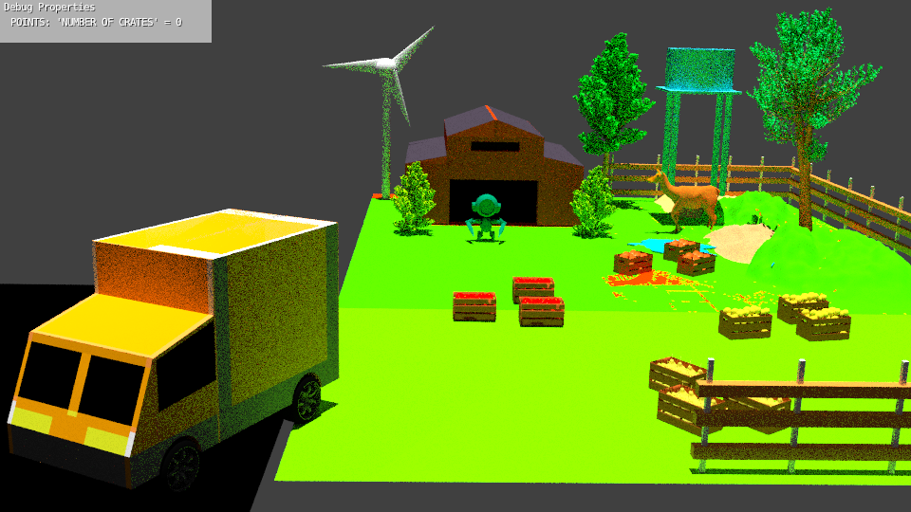

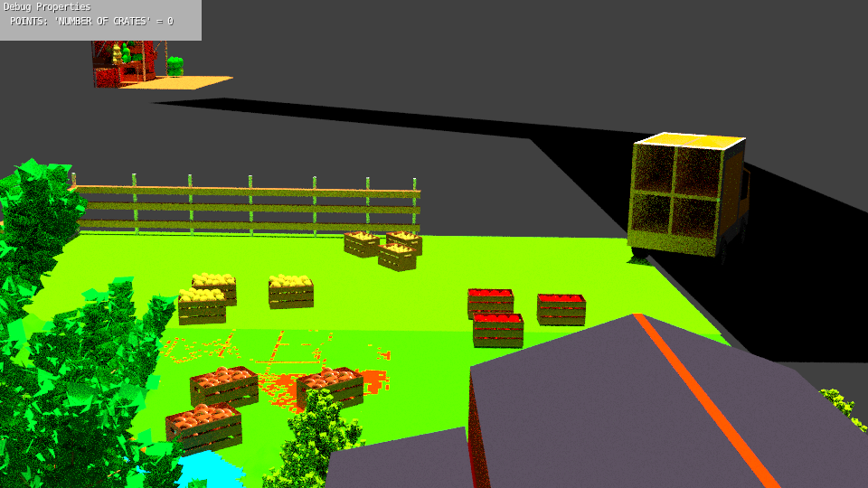

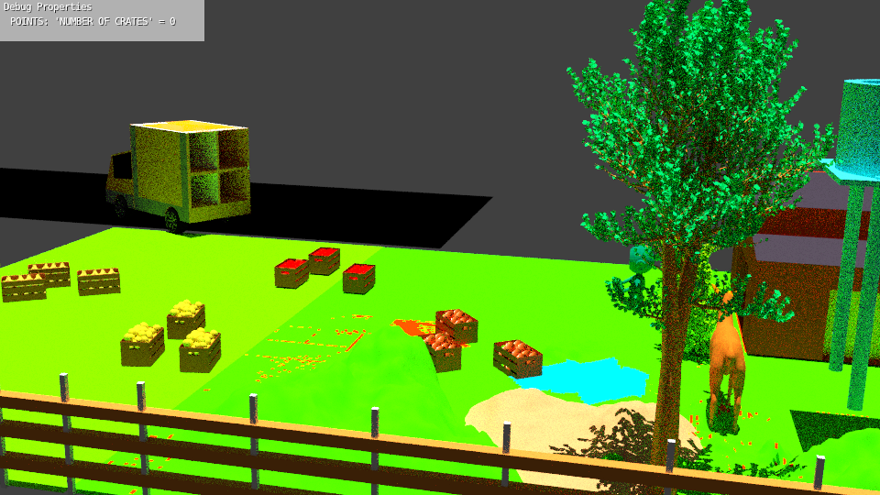

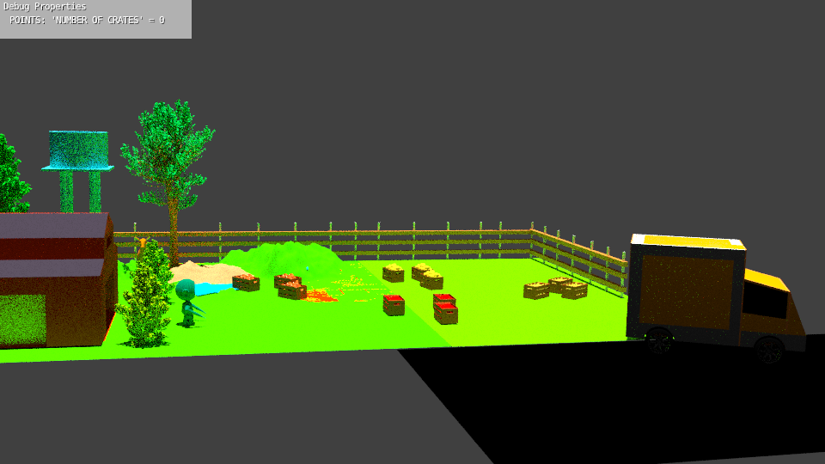

**Q10. Provide the video of Rotating Structure. (7)**

<https://youtu.be/B_Y6wymXhC8>

**Q11. Explain in brief the algorithm you will use for navigation of the arena. (08)**

Basic Motion:

* Translation: We will follow the black line using the white line sensor and count the node present on the track for localization of the bot on the track.
* Rotation: We will use Position Encoders and White Line sensors for rotating the bot. For example:

Rotating 90 degree will be when position encoder computes angle greater than 85 degree and middle white line sensor detects a black line.

Navigation between two points:

We have divided the track in three regions:

1. Region A: Track between pick up points 1 to 4
2. Region B: Track between pick up points 5 to 8
3. Region C: Track between pick up points 9 to 12

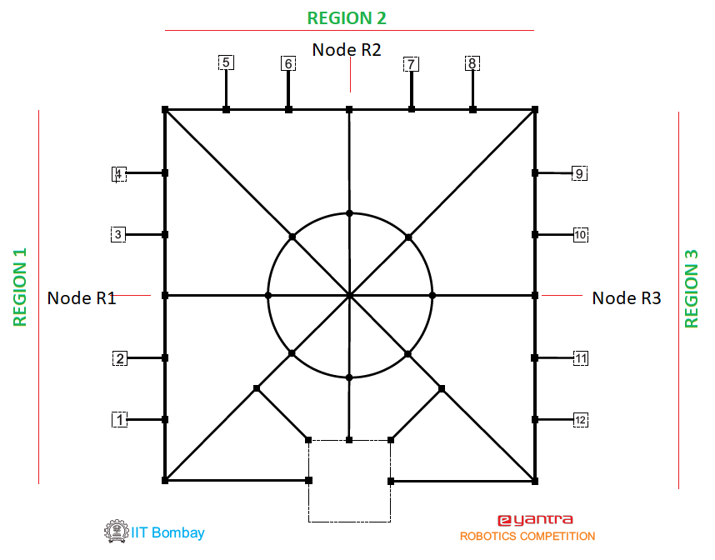

ALGORITHM:

* We will traverse the arena in Ascending order of the pickup points, i.e. if we want to go to

Pick up point 9 and 7 we will first go to pick up point 7 then after 9.

* From Start to go to the first pickup point first we will go to the NR1, NR2, NR3 depending upon the pickup point lies in which region. Then to the pickup point.
* If the next pickup number is in same region of the previous pickup number then bot will simply follow the line and go to that number else it will go to start and follow the previous step.

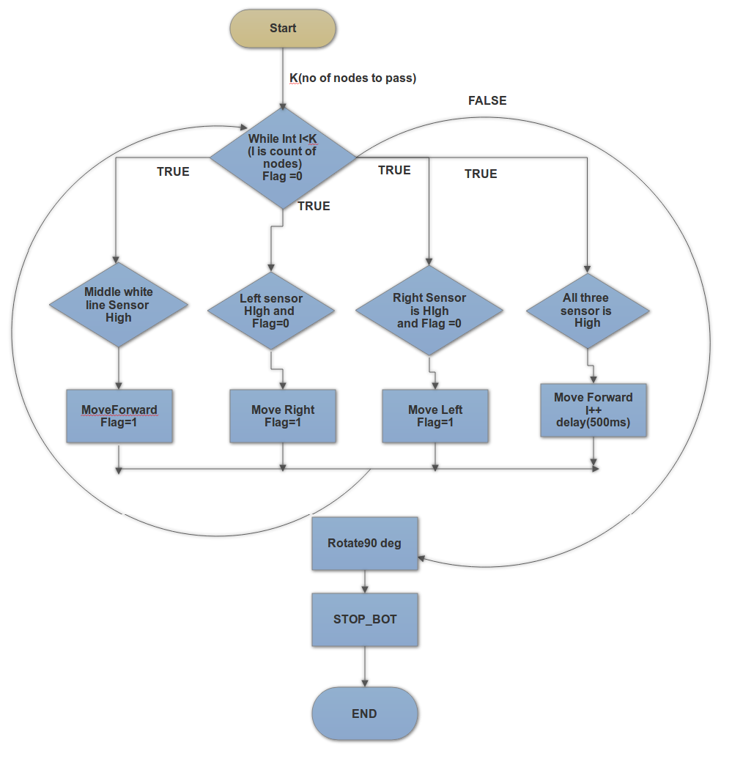

**Algorithm Analysis**

**Q12. Draw a flowchart illustrating the algorithm you propose to use for Blender.**

**(Include the action undertaken in blender like how robot picks the Crate, drops it in Truck using the information received from Firebird V) (5)**

1. Select GAME LOGIC and BLENDER GAME
2. Go to templates- Python-Simple Game Logic

Apply code:

**Import Serial (‘port’,’baudrate’,timeout)** //( imports the serial data from xigbee to python given by firebird V)

(It sends data after a particular time interval . if the data matches the requirement the game runs.)

**If ser.readline(“ .”)**

**Player.applyMovement((0,0,9), True)**

**Player.applyRotation((0,0,4), False)** // which move the robot to the destination

1. Select ROBOT ( LOGIC BRICKS)

Sensors – always

Controller- python(select the template file)

Join the bricks.

1. Add a crate(**pickupcrate**) and parent it to the Robot( go to properties- physics- invisible(crate)).
2. Select crate 1(LOGIC BRICKS):

Sensors-keyboard(“A”)

Controller-AND

Actuators- visibility(turn down the crate1 visibility)

Select pickupcrate:

Actuators- visibility(turn on the pickupcrate visibility)

Join all the bricks.

Again firebird V sends the data if it matches the “A” it picks the crate.

**(THAT’S HOW YOU PICK THE CRATE)**

1. Now again ,

**Import Serial (‘port’,’baudrate’,timeout)** //( imports the serial data from xigbee to python given by firebird V)

(It sends data after a particular time interval . if the data matches the requirement the game runs.)

**If ser.readline(“ .”)**

**Player.applyMovement((0,0,9), True)**

**Player.applyRotation((0,0,4), False)** // which move the robot to the destination

It reaches the truck

1. In game,

ADD carte (**dropcrate**) and place it inside the truck at the drop point.

Go to properties-physics (turn it invisible)

1. Select pickup crate (LOGIC BRICKS):

Sensors-keyboard(“D”)

Controller-AND

Actuators- visibility(turn down the pickupcrate visibility)

Select dropcrate:

Actuators- visibility(turn on the dropcrate visibility)

Join all the bricks.

Again firebird V sends the data if it matches the “D” it drops the crate.

**(THAT’S HOW YOU DROP** **THE CRATE)**

**Q13. Draw a flowchart illustrating the algorithm you propose to use for theme implementation. (5)**

**WE will pick all the objects first and drop in a rotating box attacked to our bot at the right . After picking all the blocks it will go to deposit point and deposit the blocks.**

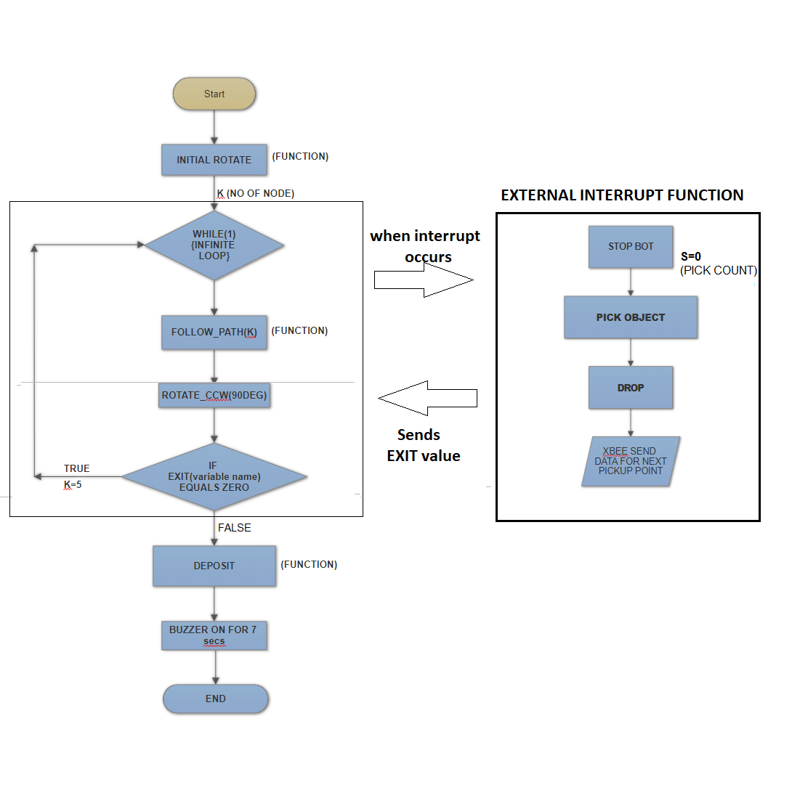

ALGORITHM – MAIN FUNCTION

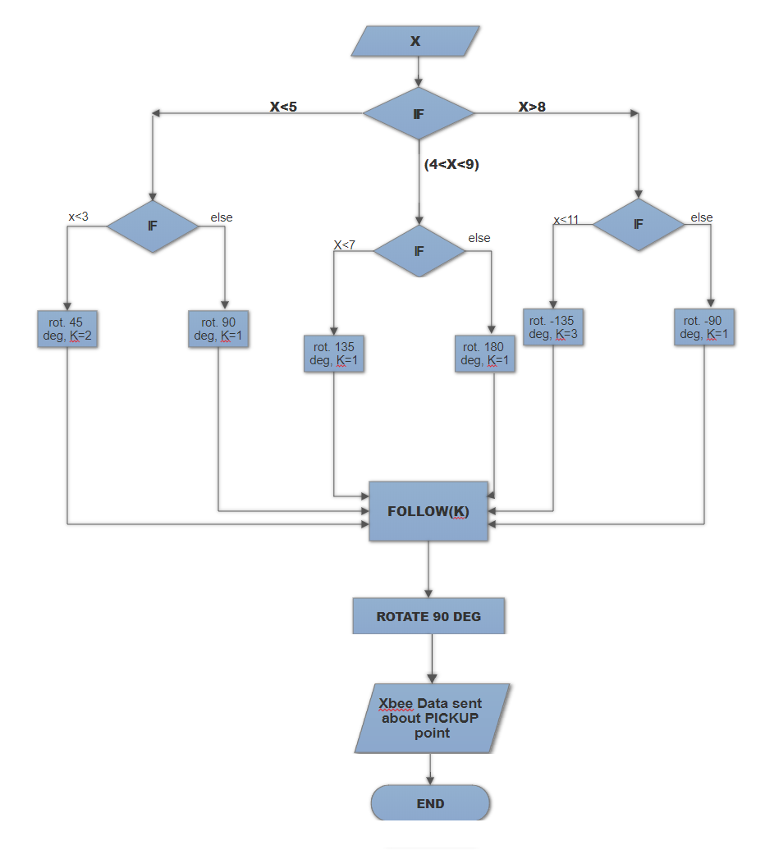

**INITIAL ROTATE**



FOLLOW PATH

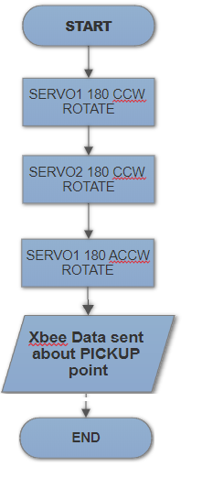

PICK UP

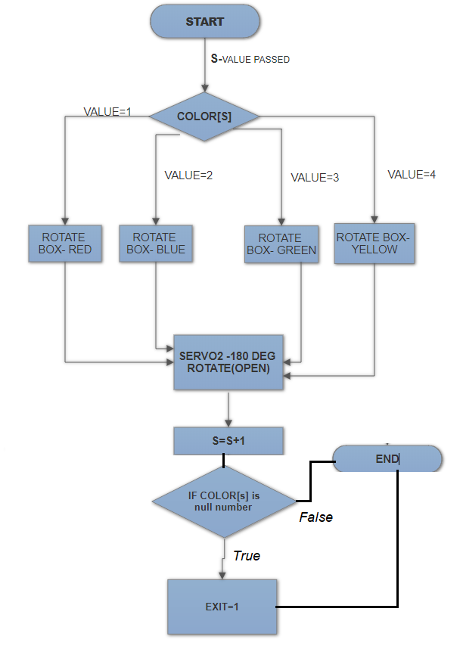 DROP(ABOVE PIC)

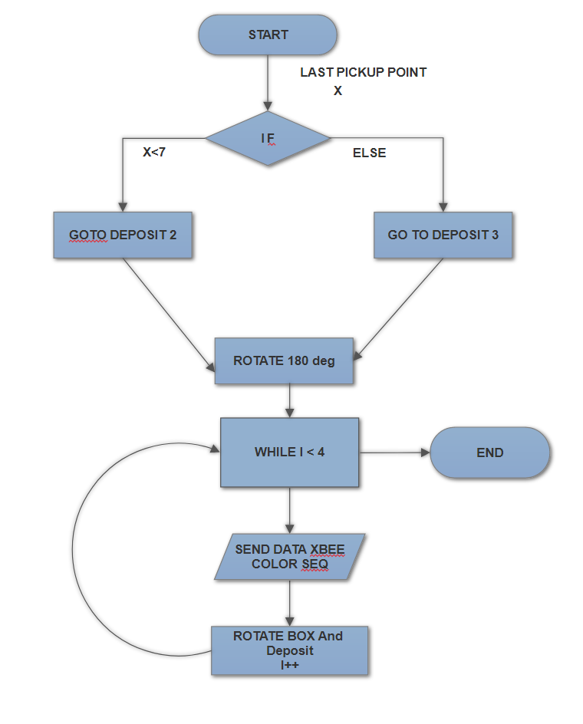

DEPOSIT(ABOVE PIC)

**Challenges**

**Q14. What are the major challenges that you can anticipate in addressing this theme and how do you propose to tackle them? (5)**

**CHALLENGE 1: PROCESSING SPEED OF BLENDER GAME**

1. At the time of running the game. It takes too long to respond (start the game) or sometime even show not responding.

It happens due to the number of objects and their textures etc. we used in cycles render which makes the game too slow as it increases the time of analysing and synchronising

The whole arena in blender game which is the main cause of slow processing.

**HOW TO TACKLE:**

1. We reduce the number of objects either by joining two or more objects as one object and remove the textures of all objects as it won’t have any effect on blender game.
2. By doing this we make the game process faster.

**CHALLENGE 2: MOTOR SPEED(RPM)**

1. Both motors of robot has different rotations per minute(RPM) which makes it difficult to move it around at a particular point. As each motor rotates at it’s own RPM instead of going straight it rotates before destination due to different speeds of motor.

**HOW TO TACKLE:**

1. First we find error ( how much it differs from the other motor) of the motor by the method of PWM we find a common speed for the motors to operate.
2. Thus we synchronize the motors make the robot move to desired point.

**CHALLENGE 3: ROBOT PATH**

1. To reach at some place there are different paths to get there. We challenge in select the path between the crate and robot so that the paths should be shortest and code become simple and efficient.

**HOW TO TACKLE:**

* By analysing all the possible paths on which robot can get to the respective place and thinking all the different algorithms and conditions. we come to conclusion which consumes a lot of time.

**CHALLENGE 4: GRIPPER MECHANISM**

1. For designing of gripper mechanism so that it takes less time and is efficient in terms of working. How it can match with the mechanism of robot where to place it of what dimensions keeping in mind all the movement of the robot it’s motion , crates dimensions etc. so that it meets the requirements.

**HOW TO TACKLE:**

1. By hit and trial methods many times ,taking references from different sources analysing the structure and it’s placement thinking of possible results.

**CHALLENGE 5: MODELLING OF GAME**

1. Making different models for game was the most difficult task . since we were completely new to blender it takes a long time and hardwork to get perfection in it. making different models combing in one creating models according to scene requirement etc.

**HOW TO TACKLE:**

1. We learn about different aspects of blender through the tutorials provided and other sources which takes time .
2. Apply those learning to blender and get the required model and also how to do different other things apart from modelling (e.g desining the game etc.)